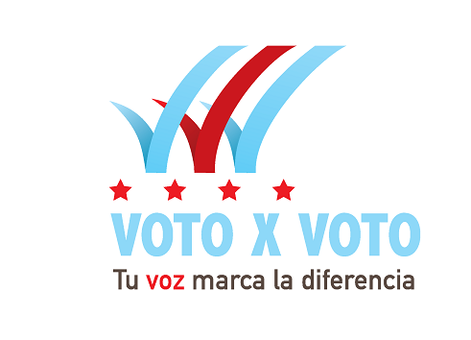
Press Release—

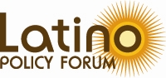
Adriana Díaz, Communications Manager
312-376-1761
312-860-5120 (cell)
adiaz@latinopolicyforum.org

Illinois Latino Agenda co-hosts Chicago Mayoral Candidate Forum

Urges voters to become informed and vote February 24

Chicago—February 13, 2015— All five candidates for Mayor of Chicago––Rahm Emanuel, Bob Fioretti, Jesus "Chuy" Garcia, William "Dock" Walls and Willie Wilson––participated in a livestreamed forum Friday co-hosted by the Illinois Latino Agenda and Univision Chicago.

Looking to the municipal election on February 24, the Illinois Latino Agenda, the largest coalition of Latino-led nonprofits in the state, aimed to spike voter engagement by arming voters with relevant information.
As the only 2015 candidate event that focused on issues impacting Latino residents, the forum provided each candidate time to outline their vision for improving the lives of Latinos; their families and children.

“It’s about making an informed decision,” said Celena Roldán-Moreno, executive director of Erie Neighborhood House and member of the Illinois Latino Agenda. “We all have a role in engaging Latinos in the political process, which starts with providing information that’s pertinent and accessible.”

Voto X Voto—or Vote by Vote—is an Illinois Latino Agenda initiative that focuses on the exponential power an individual vote can have on communities and the potential influence Latino voters could have on elections. Latino voters, a growing share of the City’s electorate, will play a major role in determining who is elected Mayor of Chicago.

“It’s very important each voter takes the time to become informed on candidates’ platforms on the issues that will affect their lives and communities,” said Maricela Garcia, CEO of Gads Hill Center and chair of the Agenda’s civic engagement committee. “It’s just not sufficient enough to say we’re growing as a community. Latinos have to assert their political power and vote to ensure influence over the way Chicago is governed.”

About the Illinois Latino Agenda
The Illinois Latino Agenda, the largest coalition of Latino-led nonprofits in Illinois, is committed to securing equitable resources and investment for Latinos while building their power, influence, and leadership through a strategic alliance of Latino nonprofits and allies in the state. With nearly 50 member organizations across the
Chicago metropolitan region, the Illinois Latino Agenda reaches more than 250,000 individuals, families, and business owners each year through direct assistance and indirect services in a range of areas, including health care, family services and education.

About the Latino Policy Forum
The Latino Policy Forum is the only organization in the Chicago area that facilitates the involvement of Latinos at all levels of public decision-making. The Forum conducts analysis to inform, influence and lead. Its goals are to improve education outcomes, advocate for affordable housing, promote just immigration policies, and engage diverse sectors of the community, with an understanding that advancing Latinos advances a shared future. For more information, visit www.latinopolicyforum.org.
###

